IOT BASED SMART CROP PROTECTION SYSTEM FOR AGRICULTURE

ASSIGNMENT 3: PYTHON PROGRAMMING CODE

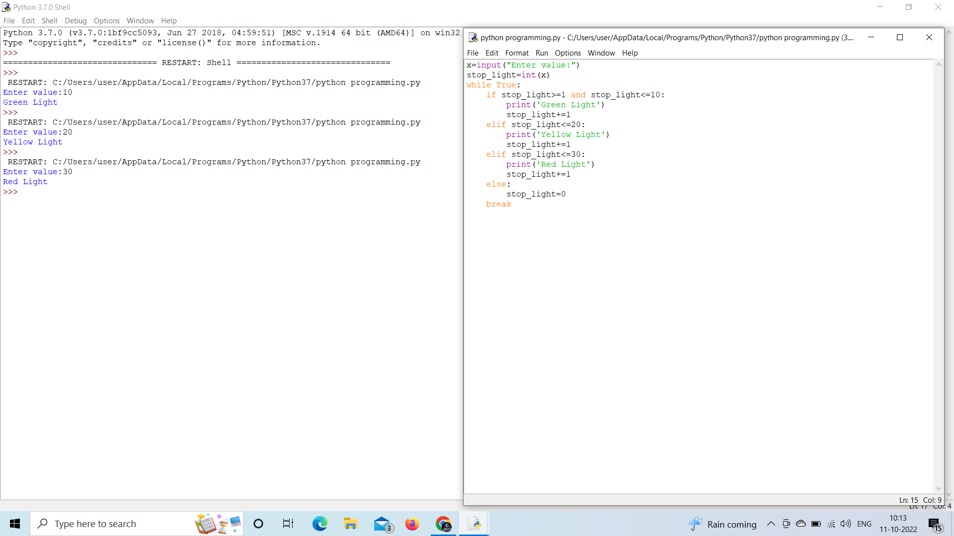OUTPUT: